Attendance System Log In

What you need to Know:
- This is Not Done First – After you sell to customers in line
- Every student logs in on the attendance roster
- You do this after you assist customers with sales
- You must log in for your shift to earn 25 points
- If you forget to log in, and I can verify you were there, it is -5 points.

- In classroom, move mouse to wake up the Attendance computer
- Select the Navigation Form Option – Opens the Navigation form
- Select the Login Form Tab for your regular shift, or Makeup Tab for a make-up shift
- Enter Your Employee ID (not your lunch code)
3
- Select the Save and Close Button
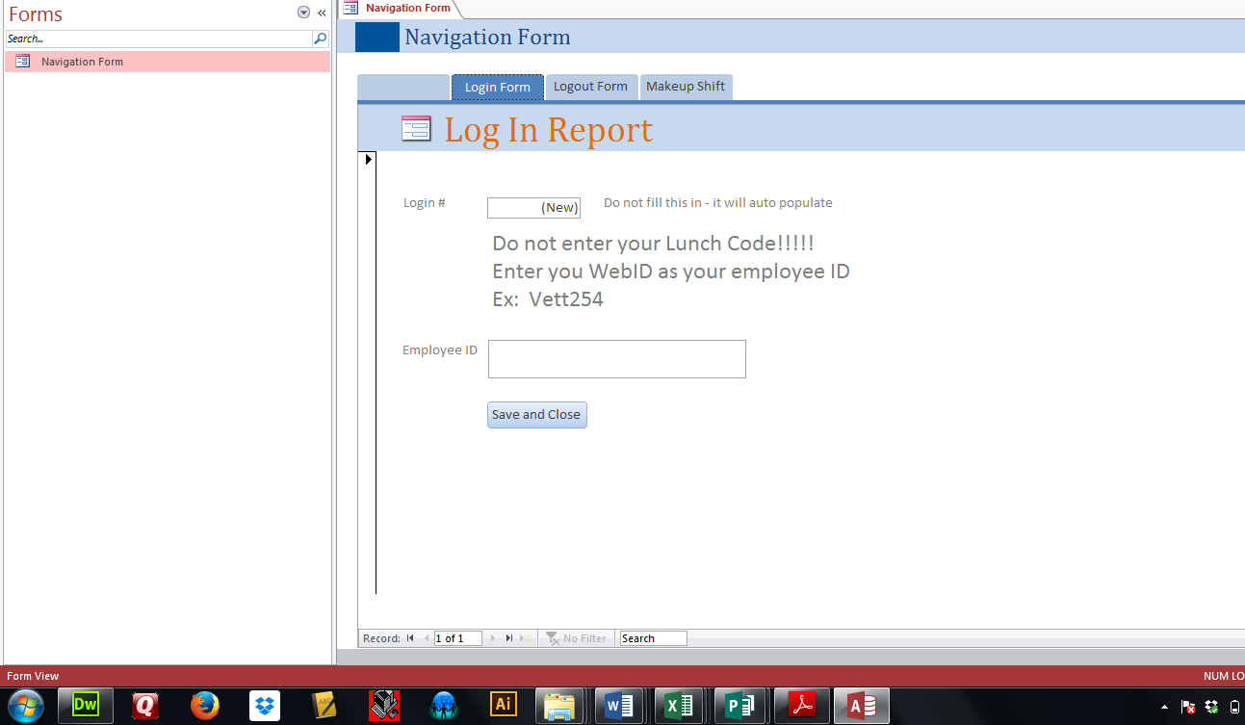
2
4
Vett254
5

